# Hawthorn

## Sceach gheal (Crataegus monogyna)

Hawthorn or white thorn was planted in hedges throughout our countryside. Its sweet smelling ‘May’ blossom is a feature in that month, and in autumn and winter the deep red haws colour the bare twigs. They are among the berries most favoured by birds. Only untrimmed hawthorn can flower and fruit freely, but hedges have to be cut to keep them stock proof. Hawthorn hedges may be trimmed regularly, or left for several years and then laid by cutting part way through the main stems and laying these horizontally through the hedge. Even old hawthorn hedges will regenerate if trunks are cut back to base and left to sprout again, but these must be fenced off so that farm livestock cannot reach the tasty young shoots and eat them. Like many other shrubs, hawthorn also grows in woodland where there is enough light – in open glades, along ‘rides’ through the woodland, or along the edge. A single tree may be left in a field as a ‘fairy thorn’, especially where there may be an archaeological site.

Mature tree –

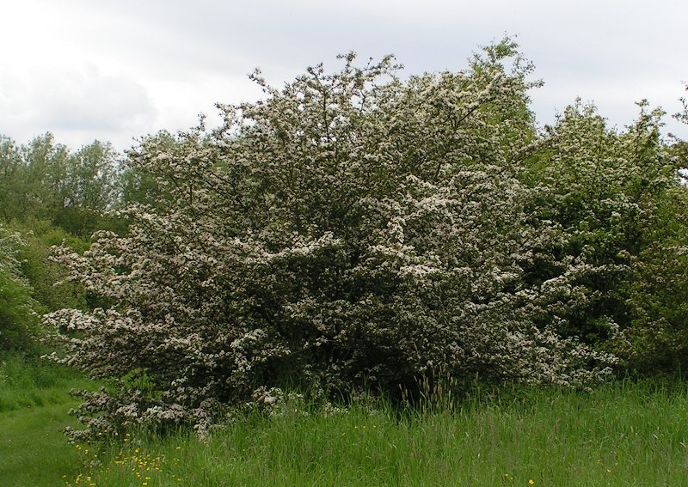

**Flowers and Fruit**

Hawthorn flowers in early Spring, this is known as ‘May Blossom’. The tree or bush is covered with a profusion of small, white flowers.  
In the autumn, the flowers form 1cm long dark red berry-like fruits known as ‘***haws’***.  These can be used for jelly or jam making.

Flower

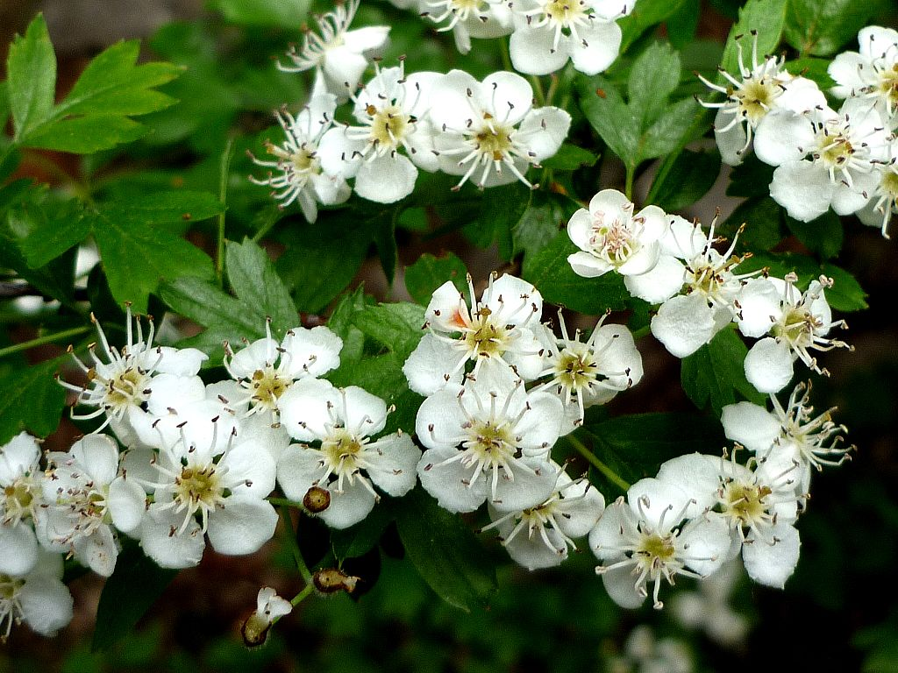

Fruit

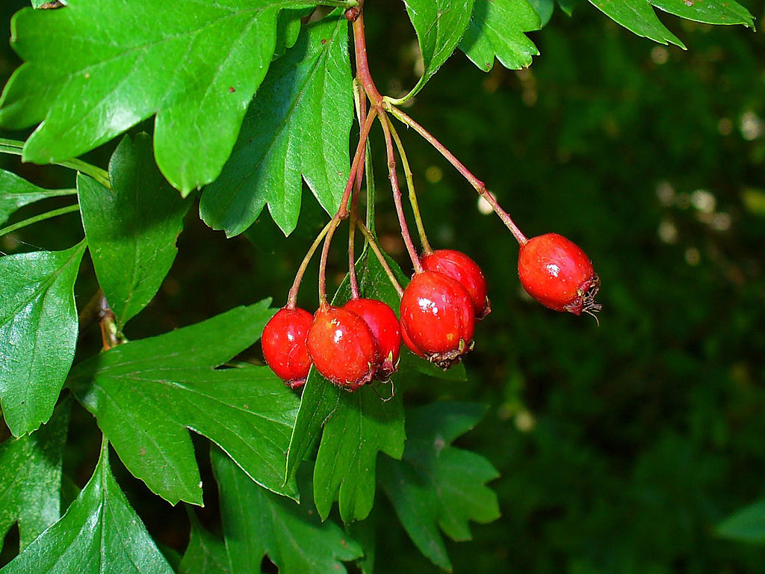

### **Bark**

### The bark is brown with occasional orange cracks, sometimes green algae may be found along the bark. The younger twigs have spikes or thorns along them – hence its name!

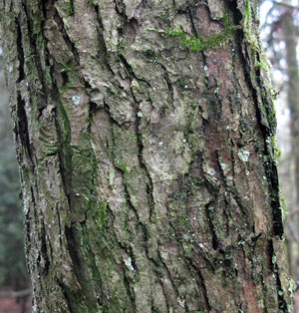Mature Bark

Young twig with spine

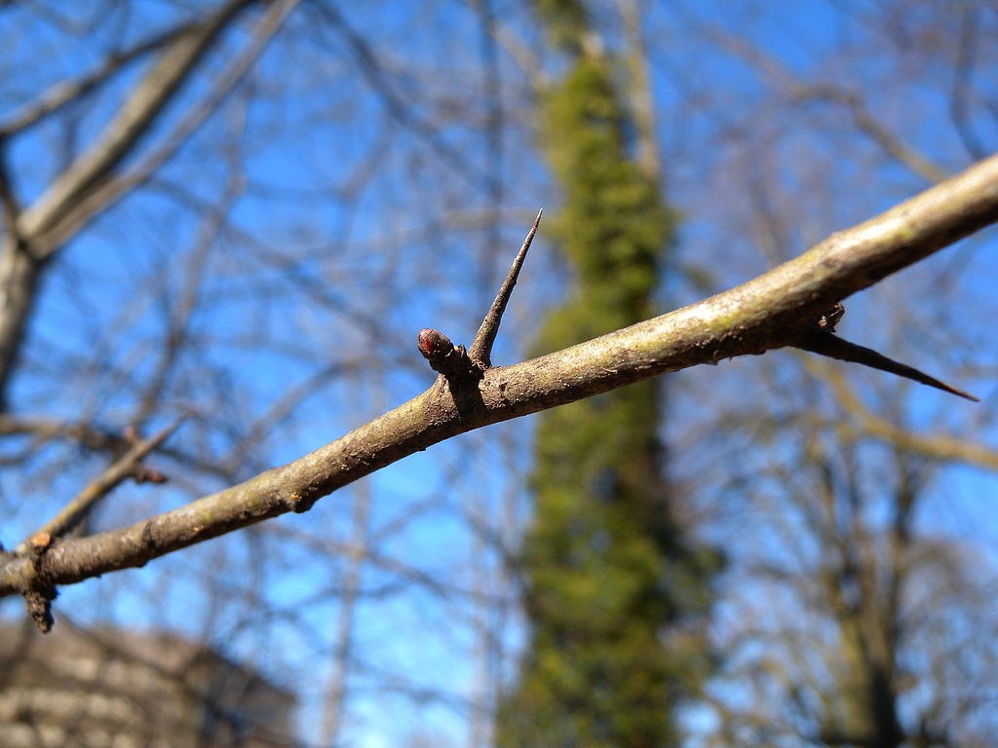

### **Leaves**

Simple leaves that are roughly as broad as they are long. They are small and deeply lobed, so that each leaf almost looks divided.

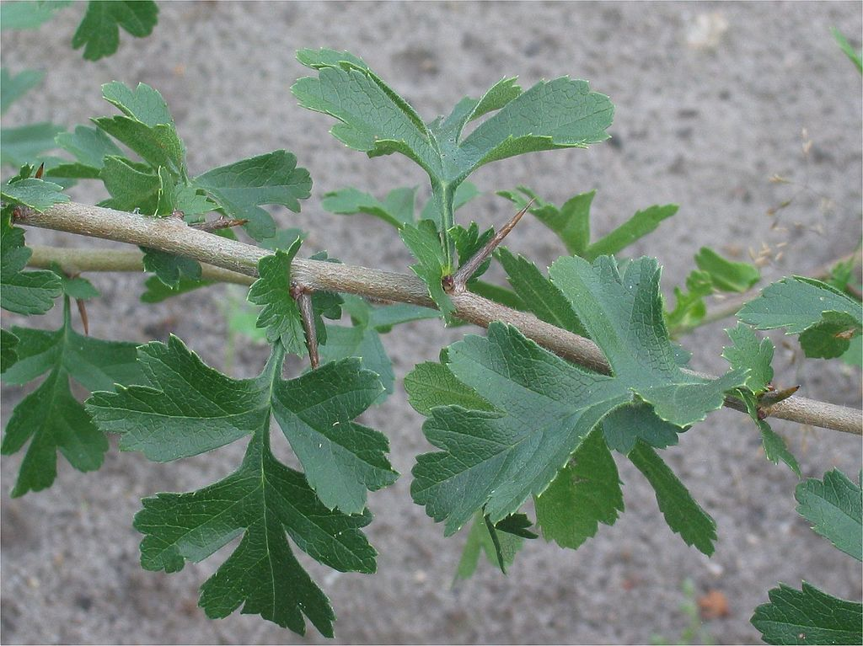

Botanical Illustration

